International consortium for cardiac tissue engineering

Kick-off Meeting at EACTS in Vienna 2009

Date: 20, October 2009 (Tue)
Time 12:45–14:00
Venue: Austria Center Vienna
(Room 8Y on the Yellow Level, Ground Floor)

Coordinators
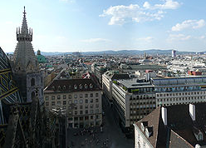

Prof. Axel Haverich
Hannover Medical School, Germany

Prof. Ari Harjula
University of Helsinki, Finland

Prof. Yoshiki Sawa
Osaka University, Japan

Participants

Drs. A. Hilfiker, H. Goerler, M. Ono, H. Hata (Hannover)

Drs. E. Kankuri, A. Silttanen, H. Uenaka (Helsinki), J. Bizik(Slovakia)

Drs. S. Miyagawa, K. Takeda, H. Ide, Y. Shudo (Osaka)

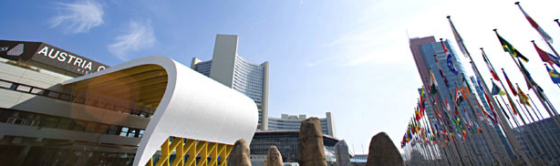

Program
Kick-off remarks:
Finnish coordinator: Prof. A. Harjula

Japanese coordinator: Prof. Y. Sawa

German coordinator: Prof. A. Haverich (H. Goerler)

Recent scientific achievements
Osaka University: Dr. S. Miyagawa

University of Helsinki: Dr. E. Kankuri

Hannover Medical School: Dr. A. Hilfiker

Plan and grant
Dr. M. Ono

Presentation of the next meeting & closing remarks
Prof. Y. Sawa

Note
1. Austrian lunch will be served during the meeting!

2. A small pre-meeting is scheduled in the afternoon 19th Oct.

3. Further information comes soon. Please check our internet site.

http://jsps-osaka-u.jpn.org/en/index.html

14. Sep. 2009. M.Ono

